Background and Motivation

Game based on the already popular and successful game Pokémon, by Nintendo. The game idea is a 1vs1 turn based battle game with multiple characters to choose from and different attacks and abilities. Each player is given a turn to make a move to attack which lowers the opponents hp, some moves can be used to increase ones own hp and others to defend against attacks. The one who losses all of their hp first is the loser

Super powers? In the case that a battle is long drawn out the more that a character is attacked it gains a power in order to unleash a much more powerful attack to end the game

P v p mode? This is player1 vs player2

Single player mode? Player vs computer ? AI

Tournament mode?

Ladder mode?

Idea to base most of the characters on CS department Staff given permission

Attractive display, graphics and guis

Clear and easy to use guis

Problem Statement

The idea of a Pokémon based game is challenging in many aspects since not only is the original game very complicated and complex with hundreds of different characters and abilities, but it is also not in our teams moral interest to completely rip off a game that already exists and produce something that is far lesser than the original. This would show a lack of creativity.

Another issue is being able to create a balanced game, with this level of complexity and number of different characters it is quite difficult to make sure that all the characters are balanced not one of them has any ability or power level that is so much greater than the rest of them that it breaks the game and makes it boring.

Approach

Milestone 1: creating the basic code that will hold and call separate characters

Milestone 2: creating a way for characters to attack and use abilities on each other

Milestone 3: creating code necessary to cycle turn by turn and end game when hp is lost

Milestone 4: creating graphics and guis to support all the previously mentioned code

Milestone 5: creating code to call previously made code in the structure to implement the tournament mode

Milestone 6: creating code for AI/ randomised computer moves for p v E option

Milestone 7: creating a simple graphical tutorial for the player to understand how to play the game correctly

This link will direct you to the Hamilton_Go Development Gantt chart which will show the estimates the time span that the game will take to be developed. Tasks have been labelled with their estimated time frames in a 6-week period:

<https://infograph.venngage.com/infographic/thumbnail/fetch_multipage/21213003-07f6-4411-8952-1a2698823eec.png>

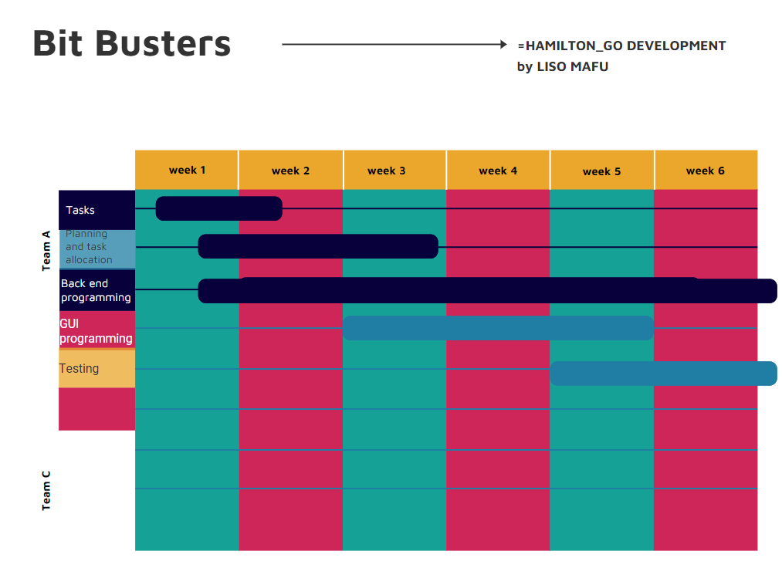

This link will direct you to the GitHub repository:

https://github.com/liso-mafu/HamiltonGo.git